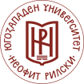
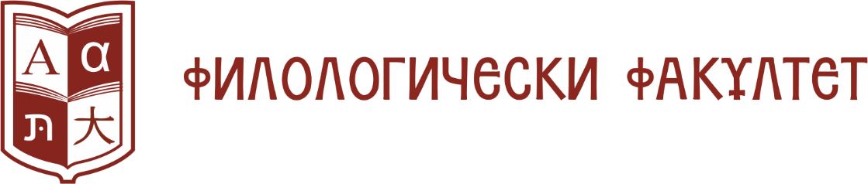

XX ANNIVERSARY PHILOLOGICAL READINGS FOR UNDERGRADUATES AND PHD STUDENTS
/Blagoevgrad, May 12, 2026/

I N V I T A T I O N

Dear colleagues Bachelor, Master and PhD Students of Philology from Bulgarian and foreign universities!

On May 12, 2026 (Tuesday) the Faculty of Philology at the South-West University – Blagoevgrad is organizing The National Philological readings for undergraduates and PhD students for a consecutive year. We would like to kindly invite you to present your research papers on problems in the field of linguistics and literature at our conference (round table) which the Faculty of Philology is going to hold for the twentieth time.
In order to apply for the conference, it is necessary to send your research papers at conference.11.may@abv.bg. The deadline is May 1st 2026.
Traditionally, the papers will be divided into two sections – linguistics and literature. The presentation time is to be no more than 15 minutes.
The National Philological Readings are with a competitive nature and the presented studies will be evaluated by a committee constituting university lecturers and researchers. The participants who are rated first, second and third in each section will be awarded. The best research papers will be published in a collection of research papers.

We are looking forward to seeing you in Blagoevgrad!

